**Database Interaction**

**Group 1**

**Database connection:**

Our application is built using Django and utilizes the Django ORM to connect to a postgreSQL database. The connection is created using connection strings found in our settings file.

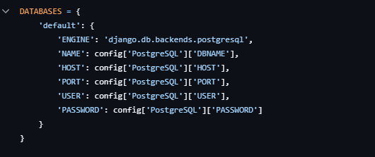

*Database connection found in settings.py*

**Query Execution:**

We use the Django ORM to map our python objects outlined in our models to corresponding database tables. Queries are created and performed by the Django ORM, which utilize our serializers to prepare the data to be transmitted. The final part of communication happens in our views, where we use the Django ORM to perform actions such as creating, reading, updating, etc, entries in our database.

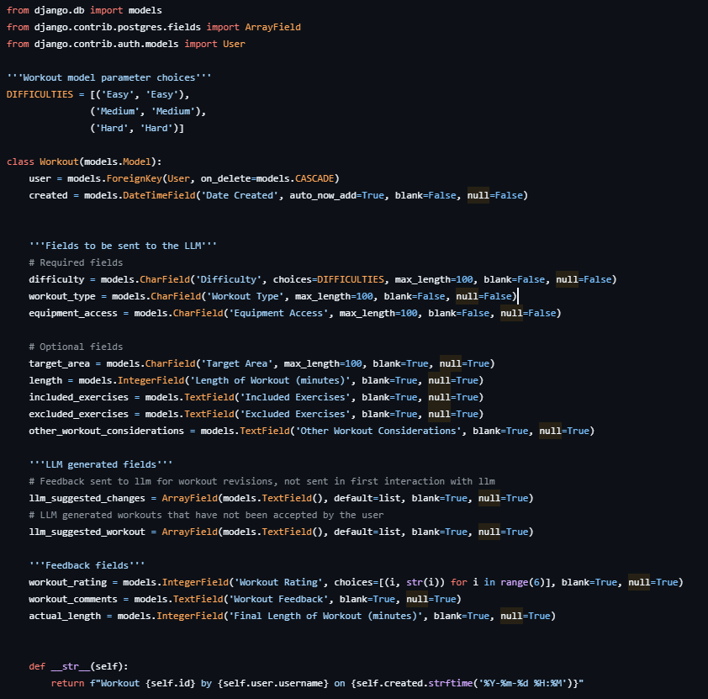

*Workout model found in workout/models.py*

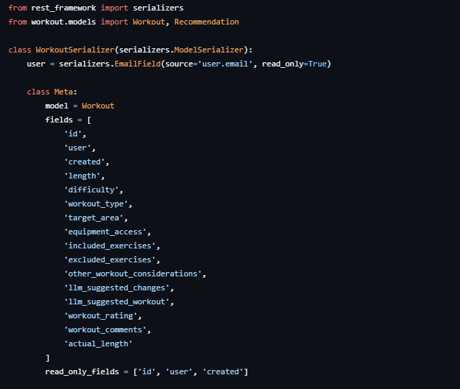

*Workout Serializer found in workout/serializers.py*

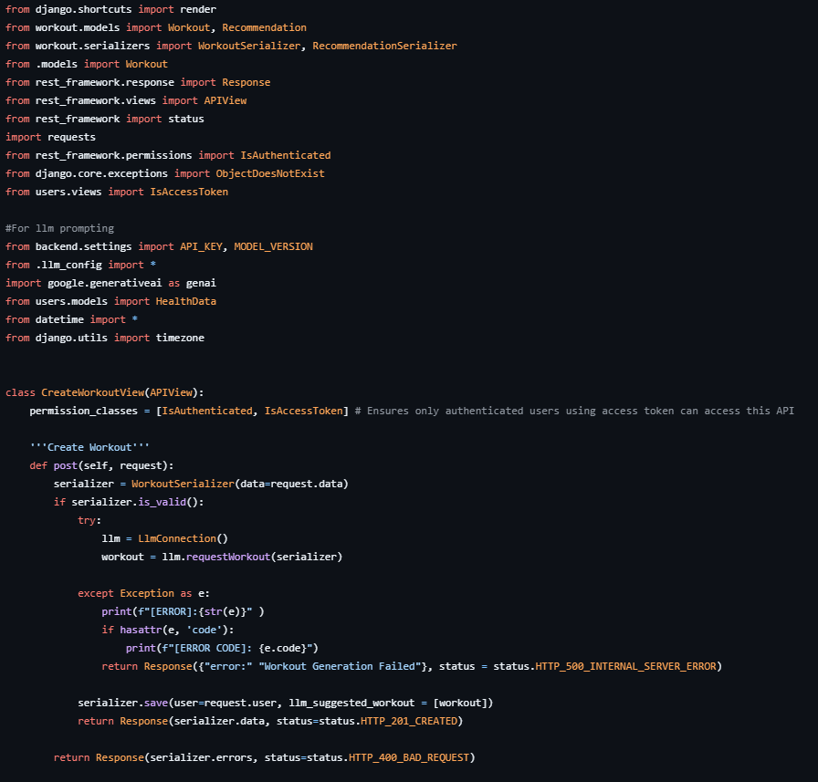

*Communication with database performed in CreateWorkoutView found in workout/views.py*